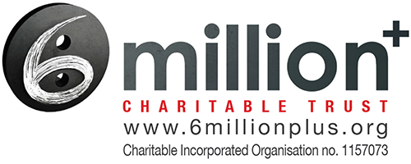

Gift Aid declaration

Please treat my gift as a Gift Aid donation (please enter amount) £

I confirm I have paid or will pay an amount of Income Tax and/or Capital Gains Tax for the current tax year (6 April to 5 April) that is at least equal to the amount of tax that all the charities and Community Amateur Sports Clubs (CASCs) that I donate to will reclaim on my gifts for the current tax year.

I understand that other taxes such as VAT and Council Tax do not qualify.

I understand the charity will reclaim 20p of tax on every £1 that I have given.

Your details here please

Title / Initial / Surname
Home address
Town
Postcode
Date

Please notify us if you:
- Want to cancel this declaration
- Change your name or home address
- No longer pay sufficient tax on your income and/or capital gains.

If you pay Income Tax at the higher or additional rate and want to receive the additional tax relief due to you, you must include all your Gift Aid donations on your Self Assessment tax return or ask HM Revenue and Customs to adjust your tax code.

Please return to: info@6millionplus.org - thanks!

